ESTIMATION OF BUSINESS EXPENSES

1.INTRODUCTION:

Business expenses refer to the costs incurred by a company in order to conduct its operations and generate revenue. These expenses are necessary for the day-to-day functioning of the business and are typically deducted from the company's revenue to determine its taxable income.

1.1 OVERVIEW

THEIR TYPE :

Business expenses refer to the costs incurred by a company in order to conduct its operations and generate revenue. These expenses are necessary for the day-to-day functioning of the business and are typically deducted from the company's revenue to determine its taxable income.

There are various types of business expenses, including:

1. Operating Expenses: These are the costs incurred in the normal course of business operations, such as rent, utilities, office supplies, salaries, and marketing expenses.

2. Cost of Goods Sold (COGS): This includes the direct costs associated with producing or acquiring the products or services that a company sells. It includes expenses like raw materials, manufacturing costs, and inventory purchases.

3. Depreciation and Amortization: Businesses may deduct the cost of certain assets over their useful life through depreciation (for tangible assets like buildings and equipment) or amortization (for intangible assets like patents or copyrights).

4. Interest Expenses: If a company has borrowed money, it will incur interest expenses on the loans. These expenses are deductible for tax purposes.

5. Taxes and Licenses: Businesses are required to pay various taxes, such as income tax, property tax, sales tax, and payroll taxes. Additionally, they may need to obtain licenses or permits for certain activities, which come with associated costs.

6. Travel and Entertainment: Businesses often incur expenses related to business travel, client meetings, and entertainment. These expenses may include airfare, hotel accommodations, meals, and entertainment costs.

7. Insurance: Businesses need insurance coverage to protect against potential risks and liabilities. The premiums paid for insurance policies are considered business expenses.

8. Research and Development (R&D): Companies engaged in research and development activities incur expenses related to scientific or technological innovation. These costs can include salaries, equipment, and materials.

Proper tracking and management of business expenses are crucial for financial planning, budgeting, and tax compliance. By monitoring and controlling expenses, businesses can optimize their profitability and make informed decisions about resource allocation.

2 .PROBLEM DEFINITION & DESIGN THINKING

2.1 Empathy Map

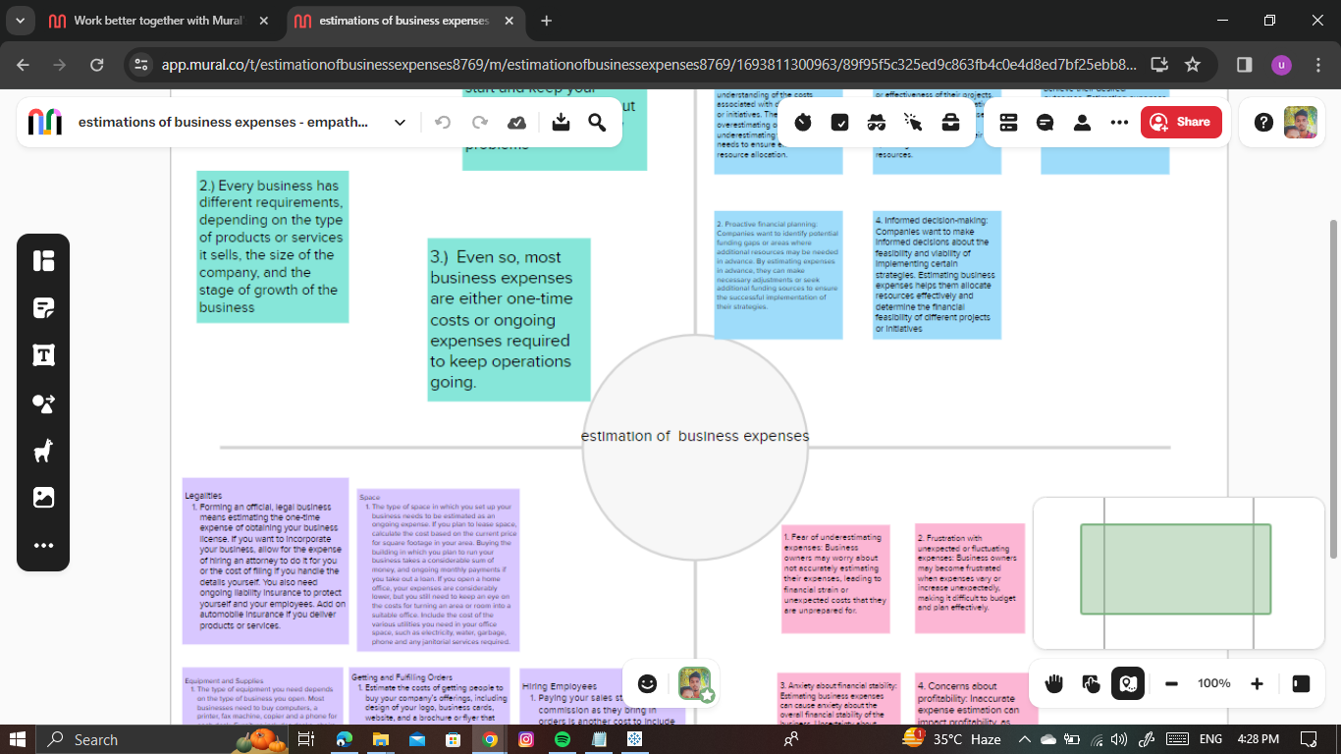

2.2 Ideation & Brainstorming Map

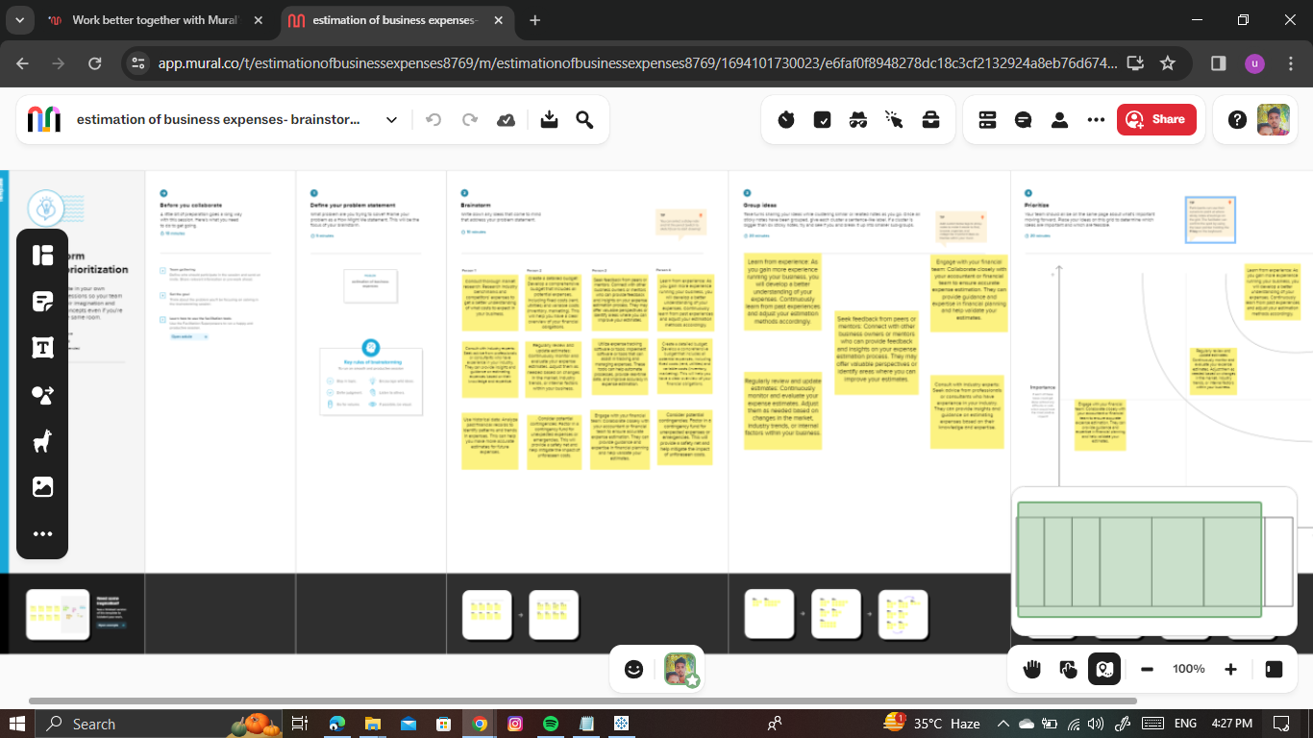

3. RESULT

The result of estimating business expenses is a clear understanding of the financial implications and requirements for running a business. This information allows businesses to plan and allocate resources effectively, ensuring that they have enough funds to cover their expenses and meet their financial goals.By accurately estimating expenses, businesses can create realistic budgets and financial forecasts. This enables them to set achievable targets and track their progress towards meeting them. It also helps in identifying areas where costs can be reduced or optimized, leading to improved profitability.Estimating business expenses also aids in project evaluation and decision-making. By understanding the costs associated with a particular project or investment, businesses can assess its viability and potential return on investment. This information allows them to make informed decisions about whether to proceed with the project or explore alternative options.Cash flow management is another crucial aspect impacted by estimating expenses. By forecasting and planning for upcoming expenses, businesses can ensure that they have sufficient cash on hand to cover their obligations. This helps in avoiding cash shortages or the need for emergency borrowing, which can negatively impact the financial health and stability of a business.Pricing strategy is also influenced by estimating expenses. By understanding the costs involved in producing and delivering a product or service, businesses can set prices that not only cover their expenses but also generate a profit. Accurate expense estimation ensures that businesses are not underpricing their offerings, which could result in financial losses.Performance evaluation is another area where estimating expenses plays a role. By comparing actual expenses against estimated ones, businesses can assess their financial performance and identify areas for improvement. This information helps in making adjustments to operations, cost control measures, and strategic planning to enhance overall performance.Lastly, accurate expense estimation is crucial for financial reporting. It ensures that businesses provide reliable and transparent financial statements, which are essential for stakeholders such as investors, lenders, and regulatory bodies. Accurate reporting builds trust and credibility, which can positively impact a business's reputation and access to capital.In conclusion, the estimation of business expenses is a vital tool for effective financial management. It provides businesses with the necessary information to make informed decisions, control costs, and plan for future success. By accurately estimating expenses, businesses can optimize their financial resources, improve profitability, and ensure long-term sustainability.

4. ADVANTAGES & DISADVANTAGES

Advantages of estimation of business expenses:

1. Financial planning: Estimating business expenses helps in creating a comprehensive financial plan for the organization. It allows businesses to allocate resources efficiently and set realistic financial goals.

2. Budgeting: Estimation of expenses helps in developing an accurate budget for the business. This enables businesses to track their spending and ensure that they are operating within their financial means.

3. Cost control: By estimating expenses, businesses can identify areas where costs can be reduced or eliminated. This helps in controlling expenses and improving profitability.

4. Decision making: Estimation of expenses provides businesses with valuable information for making informed decisions. It helps in evaluating the feasibility of new projects, investments, or expansions.

5. Cash flow management: Estimating expenses allows businesses to forecast their cash flow requirements accurately. This helps in managing working capital effectively and ensuring that there is enough liquidity to meet financial obligations.

Disadvantages of estimation of business expenses:

1. Inaccuracy: Estimating expenses involves making assumptions and predictions, which may not always be accurate. This can lead to deviations from the estimated figures and result in financial instability or unexpected costs.

2. Time-consuming: Estimating expenses requires careful analysis and research, which can be time-consuming for businesses. It may involve collecting data, conducting market research, or consulting experts, which can delay decision-making processes.

3. External factors: Estimation of expenses may be influenced by external factors such as changes in market conditions, government regulations, or economic fluctuations. These factors can make it challenging to accurately predict future expenses.

4. Lack of flexibility: Once expenses are estimated and budgets are set, it can be difficult to make adjustments or accommodate unforeseen circumstances. This lack of flexibility may hinder businesses from adapting to changing market conditions or opportunities.

5. Overlooking hidden costs: Estimating expenses may not always capture all hidden costs associated with business operations. This can result in underestimating expenses and negatively impact financial performance.

It is important for businesses to regularly review and update their expense estimates to minimize the disadvantages and ensure accurate financial planning.

5. APPLICATIONS

The estimation of business expenses is applicable in various areas of business management, including:

1. Financial forecasting: Estimating expenses helps in forecasting future financial performance, which is crucial for making strategic decisions and setting realistic financial goals.

2. Budgeting and cost control: Estimating expenses allows businesses to develop accurate budgets and control costs effectively. It helps in identifying areas where expenses can be reduced or eliminated, improving profitability.

3. Project evaluation: Estimating expenses is essential for evaluating the feasibility and profitability of new projects or investments. It provides businesses with valuable information for decision-making and risk assessment.

4. Cash flow management: Estimating expenses helps in forecasting cash flow requirements accurately. This enables businesses to manage working capital effectively and ensure sufficient liquidity for day-to-day operations.

5. Pricing strategy: Estimating expenses plays a vital role in determining the pricing strategy for products or services. It helps in ensuring that prices cover all costs and generate a profit margin.

6. Performance evaluation: Estimating expenses allows businesses to compare actual expenses against estimated figures, facilitating performance evaluation. It helps in identifying areas of improvement or cost-saving opportunities.

7. Financial reporting: Estimating expenses is necessary for preparing financial statements and reports. It provides accurate information for financial analysis, tax compliance, and shareholder reporting.

Overall, the estimation of business expenses is a fundamental aspect of financial management that supports effective decision-making, cost control, and financial planning.

6. CONCLUSION

In conclusion, the estimation of business expenses is crucial for various aspects of business management. It helps in financial forecasting, budgeting, project evaluation, cash flow management, pricing strategy, performance evaluation, and financial reporting. By accurately estimating expenses, businesses can make informed decisions, control costs, and plan for future financial success.

7. FUTURE SCOPE

The future scope of estimating business expenses is likely to expand and evolve due to advancements in technology and changes in business practices. Here are some potential areas of growth:

1. Automation and Artificial Intelligence: With the increasing use of automation and AI in various business processes, expense estimation can be streamlined and made more accurate. AI algorithms can analyze historical data, market trends, and other factors to provide more precise estimates, reducing human error and saving time.

2. Predictive Analytics: As data collection and analysis capabilities improve, businesses can use predictive analytics to estimate future expenses based on historical patterns and external factors. This can help in proactive planning and identifying potential cost-saving opportunities.

3. Integration with Financial Management Systems: Expense estimation tools can be integrated with financial management systems, allowing businesses to have real-time visibility into their expenses and financial health. This integration can enable automatic updates of estimated expenses based on actual data, improving accuracy and efficiency.

4. Industry-Specific Estimation Models: Different industries have unique expense structures and requirements. The future may see the development of industry-specific estimation models that take into account specific cost drivers and variables, providing more tailored and accurate estimates.

5. Environmental Sustainability Considerations: As businesses increasingly focus on sustainability, estimating expenses may include considerations for eco-friendly practices and initiatives. This can involve estimating the costs of implementing renewable energy sources, waste reduction measures, or other sustainable practices.

6. Integration of External Data Sources: Businesses can leverage external data sources, such as market data, economic indicators, or industry benchmarks, to enhance their expense estimation process. This can provide a broader perspective and more accurate estimates by incorporating external factors that may impact expenses.

7. Real-Time Expense Tracking: With the availability of mobile apps and digital platforms, businesses can track expenses in real-time, allowing for more accurate and up-to-date estimation. This can help in identifying cost overruns or unexpected expenses early on and taking necessary actions to mitigate them.

8. Collaboration and Data Sharing: The future may see increased collaboration and data sharing between businesses to improve expense estimation. Sharing anonymized expense data can help in benchmarking and identifying cost-saving opportunities across industries or sectors.

Overall, the future of estimating business expenses holds great potential for increased accuracy, efficiency, and strategic decision-making. Businesses that embrace these advancements and leverage technology will be better equipped to navigate the complexities of financial management and achieve long-term success.

8. APPENDIX

dashboard link 1 :

<https://public.tableau.com/views/Book1_16982980264950/Dashboard1?:language=en-US&publish=yes&:display_count=n&:origin=viz_share_link>

dashboard link 2 :

<https://public.tableau.com/views/Book1_16982980264950/Dashboard2?:language=en-US&publish=yes&:display_count=n&:origin=viz_share_link>

dashboard link 3 :

<https://public.tableau.com/views/Book1_16982980264950/Dashboard3?:language=en-US&publish=yes&:display_count=n&:origin=viz_share_link>

story link 1 :

<https://public.tableau.com/views/Book1_16982980264950/Story1?:language=en-US&publish=yes&:display_count=n&:origin=viz_share_link>

story link 2 :

<https://public.tableau.com/views/Book1_16982980264950/Story2?:language=en-US&publish=yes&:display_count=n&:origin=viz_share_link>